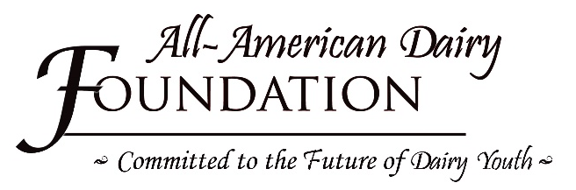
Robert D. Heilman
Youth Achievement Award
Nomination Form

The Robert D. Heilman Youth Achievement Award recognizes an outstanding youth passionate about the dairy industry who works hard, helps others, and maintains a positive attitude regardless of the circumstances. The Foundation desires to recognize a youth that people may not always notice, that does not always win the big awards, but takes in the whole experience and is always learning and improving. To be eligible, nominees must be 16 years old and must have participated in youth activities at three (3) prior All-American Dairy Shows.
To Nominate, complete the following information relating to the nominee:
Name: __________________________________________________Birthdate: __________________________
Address: ___________________________________________________________________________________
City, State, Zip: ______________________________________________________________________________
County: _____________________________4-H Club/FFA Organization: ________________________________
Breed(s) of cow exhibited: _____________________________________________________________________
Parents’ Names: _____________________________________________________________________________
Parents’ phone number: _________________________________ Parents’ email: ________________________
The recipient will be recognized in the ring while they are exhibiting on Monday. Please identify the class(es) for which their animals are entered: _____________________________________________________________
___________________________________________________________________________________________
Briefly explain the nominee’s prior participation in the Premier National Junior Show and All- American Dairy Show Youth Activities: ___________________________________________________________________
___________________________________________________________________________________________
Briefly explain why this nominee is an excellent candidate for the Robert D. Heilman Youth Achievement Award____________________________________________________________________________________________________________________________________________________________________________________________________________________________________________________________________
Nominated by: __________________________________________Phone Number: _______________________
Email: ____________________________________________ Breed Represented: _______________________
ADDITIONAL INFORMATION CAN BE INCLUDED ON A SECOND PAGE

